Assignment 1
Traffic Analysis
Wireshark Packet Capture Analysis
-
cap 4 and cap 6

1. Introduction and Objectives
Traffic analysis is an important activity in network management and cybersecurity. By inspecting packet captures, it is possible to identify communicating hosts, determine the protocols in use, reconstruct protocol operations, and identify security weaknesses supported by observable evidence.
This report analyses two packet captures, cap4.cap and cap6.pcap, using Wireshark. For each capture, the analysis identifies the communicating parties, the main protocol, the sequence and characteristics of the communication, the available evidence, and relevant security risks and mitigation measures. Findings are limited to what can be supported by the supplied captures.

2. Methodology
The captures were inspected in Wireshark using display filters and packet details. For the Telnet capture, the filter tcp.port == 23 was used and the TCP stream was inspected with Follow → TCP Stream. For the second capture, the recommended starting filter is udp.port == 1434, followed by inspection of the IP, UDP and payload fields.
A packet capture shows network traffic observed at the capture point. It does not, by itself, prove that a remote command was executed successfully, that a host was compromised, or that the sender's identity is known. These limitations are considered throughout the report.

3. Capture A — cap4.cap: Telnet Session

3.1 Intervening hosts and main protocol
The visible packets show a client at 192.168.251.1 connecting to a server at 192.168.251.11. The client uses TCP source port 36099 and connects to destination port 23, the standard Telnet port. The main protocol is Telnet over TCP.

3.2 Protocol operation and communication sequence
The first three visible packets show the TCP three-way handshake: the client sends SYN, the server responds with SYN/ACK, and the client completes the handshake with ACK. Telnet option negotiation then follows, including terminal and echo-related options. The server presents a Microsoft Telnet service welcome message and a login prompt. The supplied TCP-stream screenshot shows the negotiation and login prompt, but does not clearly show a complete successful authentication or subsequent commands.

3.3 Evidence
Figure 1 shows the display filter tcp.port == 23, the endpoints, TCP connection establishment and Telnet negotiation. Figure 2 shows the reconstructed TCP stream, including the Microsoft Telnet welcome message and login prompt. The second screenshot contains substantial negotiation/binary-looking content and does not, by itself, establish that a login succeeded.
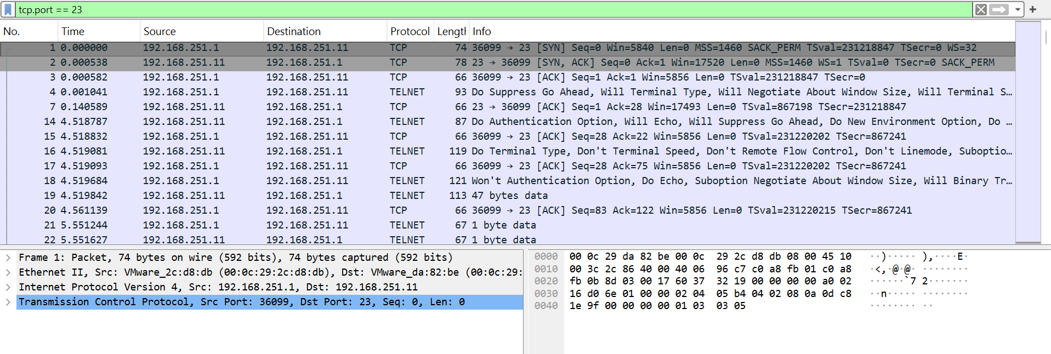
Figure 1. Telnet traffic filtered by TCP port 23, showing the client, server, TCP handshake and protocol negotiation.
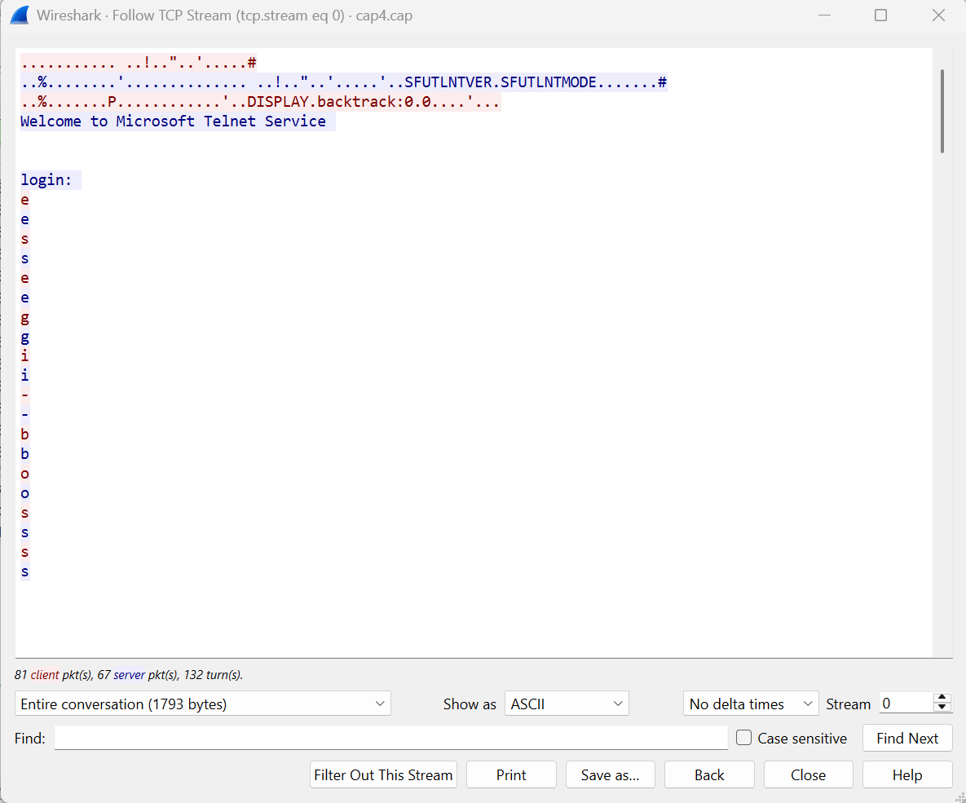
Figure 2. Follow TCP Stream output showing the Microsoft Telnet welcome message and login prompt.

3.4 Security problems and mitigation
Telnet does not provide transport encryption. Depending on the negotiated options and the captured traffic, usernames, passwords, commands and server responses may be observable in plaintext. This creates risks of credential disclosure and exposure of administrative activity to anyone able to capture the traffic. The screenshots establish that Telnet is in use, but do not alone prove credential theft or unauthorized access.
- Disable Telnet where it is not required and use SSH or another encrypted remote-administration protocol.
- Restrict remote administration to trusted management networks and apply firewall rules.
- Review authentication and system logs to determine whether the session was authorized.
- If credentials may have been exposed, rotate them and check for reuse on other systems.
Suggested Wireshark filters: tcp.port == 23; tcp.port == 23 && tcp.len > 0.

4. Capture B — cap6.pcap: UDP Traffic to Port 1434

4.1 Intervening hosts and main protocol
The initial analysis information associated with this capture identifies a UDP packet from 218.232.95.60, source port 3664, to 192.168.1.4, destination port 1434. Port 1434 has historically been associated with the Microsoft SQL Server Resolution Service. These details should be checked against Figure 3 and the packet fields in the actual capture before final submission.

4.2 Protocol operation and communication characteristics
UDP is connectionless: it does not establish a TCP-style handshake and does not guarantee delivery, ordering or retransmission. The observed packet is directed to UDP destination port 1434. Its payload has previously been described as compatible with the SQL Slammer/Sapphire worm pattern; this should be treated as a hypothesis unless the payload is visible and verified in the submitted evidence.

4.3 Evidence — screenshots to insert
Insert the two remaining screenshots in the spaces below. Ideally, Figure 3 should show the packet list with udp.port == 1434 applied and the source/destination addresses visible. Figure 4 should show the selected packet's UDP details and payload bytes. Do not claim successful exploitation based on a single packet alone.
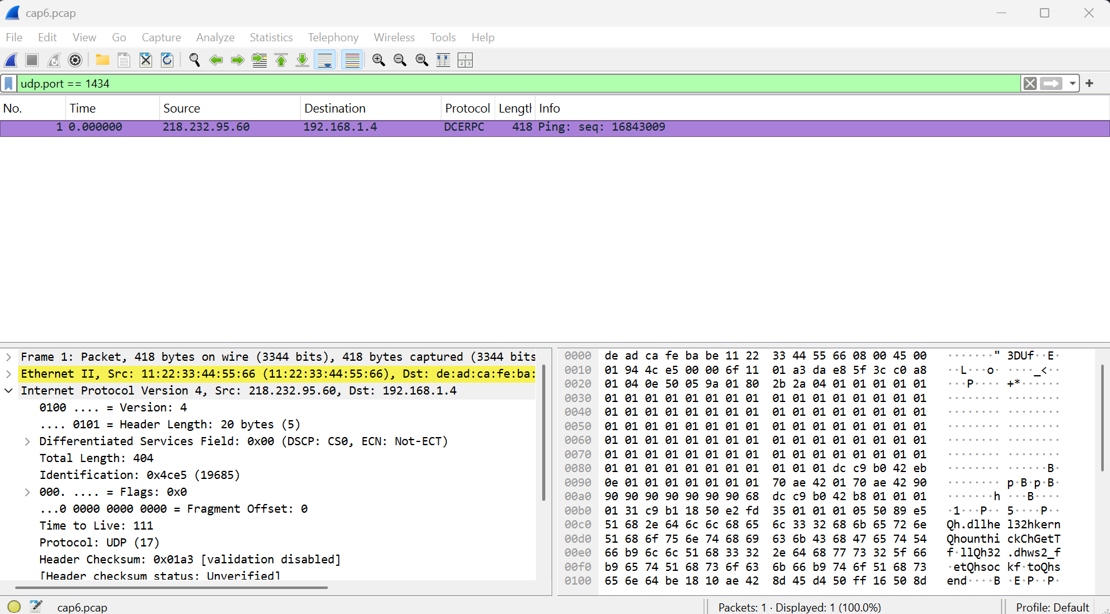
Figure 3. UDP packet directed to destination port 1434, with source and destination addresses visible.
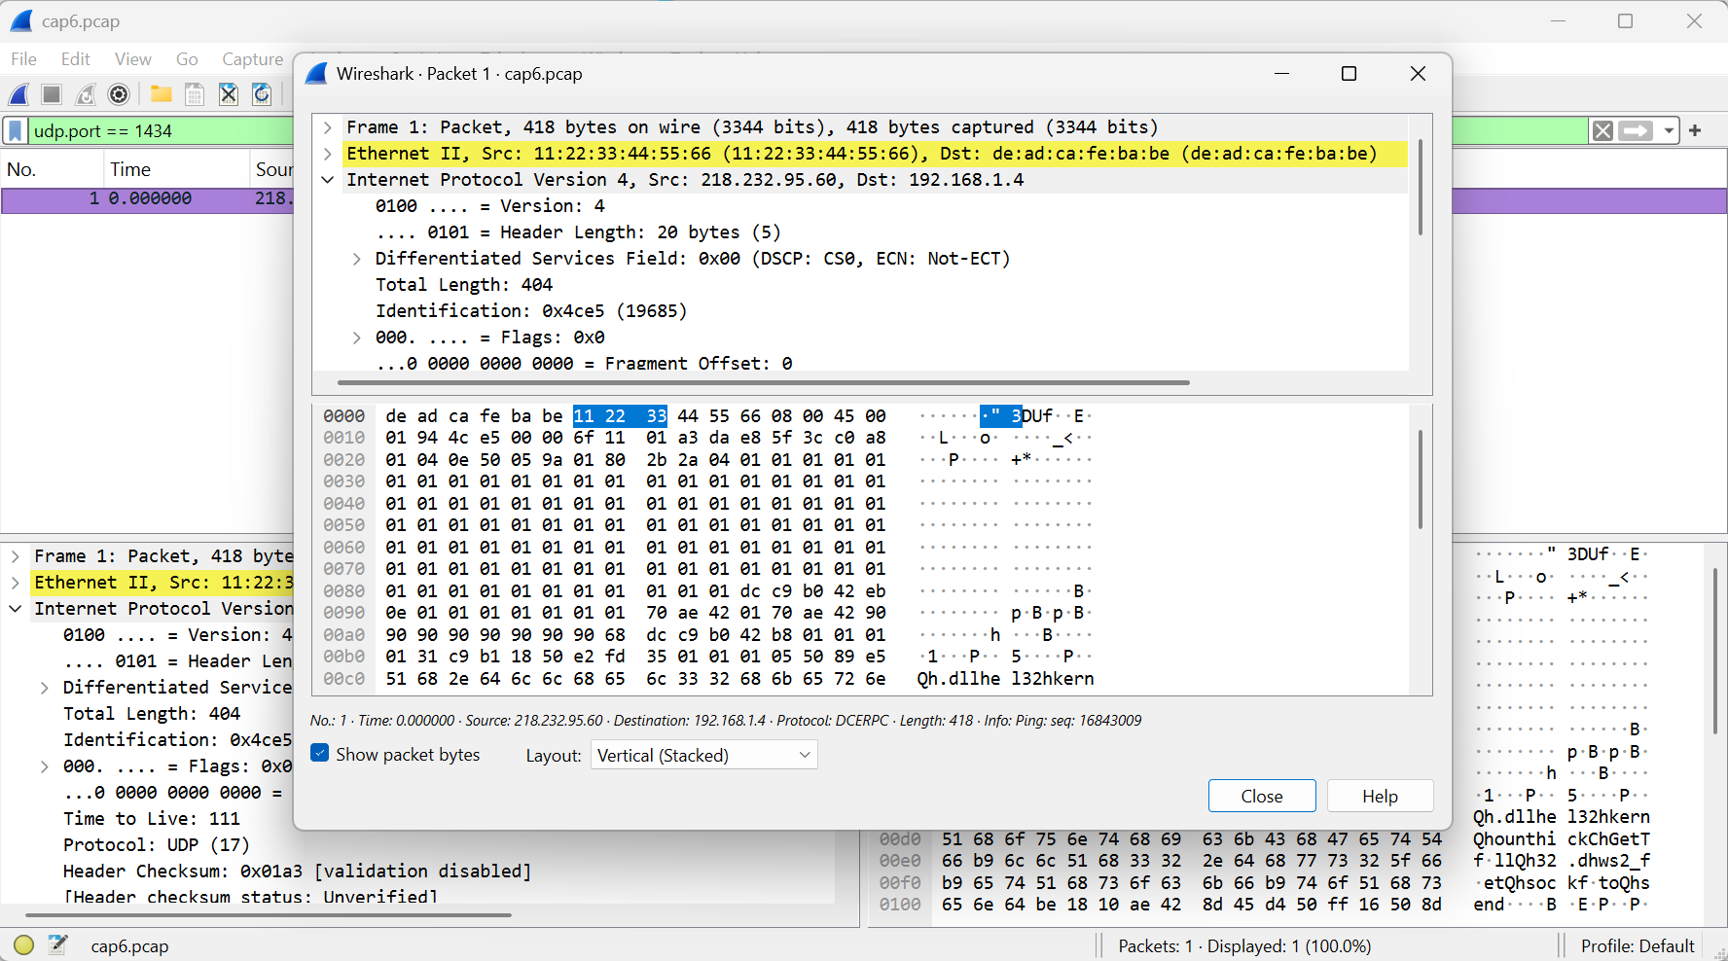
Figure 4. UDP payload inspection for the packet directed to port 1434.

4.4 Security problems and mitigation
A packet directed to UDP/1434 with a payload resembling a known SQL Slammer exploit may indicate an attempt to exploit a vulnerable SQL Server Resolution Service. The available evidence does not confirm that the destination service was running, vulnerable, or successfully exploited.
- Verify the SQL Server version and patch level, and apply the vendor's relevant security updates.
- Restrict UDP/1434 at the host and network firewalls where it is not required; validate rules against operational needs.
- Review endpoint, SQL Server, firewall and network monitoring logs for related packets or signs of compromise.
- Check whether other internal hosts received similar payloads, which could indicate scanning or propagation.
Suggested Wireshark filters: udp.port == 1434; ip.src == 218.232.95.60 && udp.dstport == 1434.

5. Summary of Findings
Capture | Main protocol / service | Observed finding | Assessment
cap4.cap | Telnet over TCP/23 | Client 192.168.251.1 connects to 192.168.251.11; TCP handshake and Telnet negotiation visible. | Use of an unencrypted remote administration protocol is confirmed. Successful login is not established by the supplied screenshot.
cap6.pcap | UDP to port 1434 | Packet reportedly from 218.232.95.60:3664 to 192.168.1.4:1434; payload requires screenshot-based verification. | Potential exploit traffic; SQL Slammer compatibility and any compromise require validation.

6. Conclusion
The first capture confirms the use of Telnet, an unencrypted remote-administration protocol that can expose session data to traffic observers. The second capture is reported to contain a UDP packet directed to port 1434, a service historically associated with Microsoft SQL Server Resolution Service; the payload may be consistent with known exploit traffic, but this assessment must be confirmed from the packet evidence. Recommended actions include replacing Telnet with an encrypted protocol, reviewing authentication logs, patching affected services, and restricting unnecessary network exposure. The captures support identifying security risks, but do not alone prove that either host was compromised.

Appendix — Screenshot checklist
- Figure 1: cap4.cap — tcp.port == 23, endpoints and packet list.
- Figure 2: cap4.cap — Follow TCP Stream; ensure the relevant text is visible if available.
- Figure 3: cap6.pcap — udp.port == 1434, packet list and IP addresses.
- Figure 4: cap6.pcap — UDP details and payload bytes.

